Name: D. Bala Charan ID number: 2520090087
Week 1
SESSION-1
Task 1: To Install Linux VM, Configure GCC, Setup Git Repository, Create Project Structure, Understand Shell Architecture, Build Initial Make file.

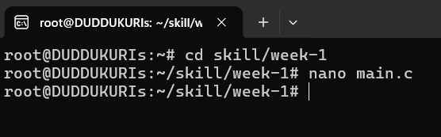
CODE:
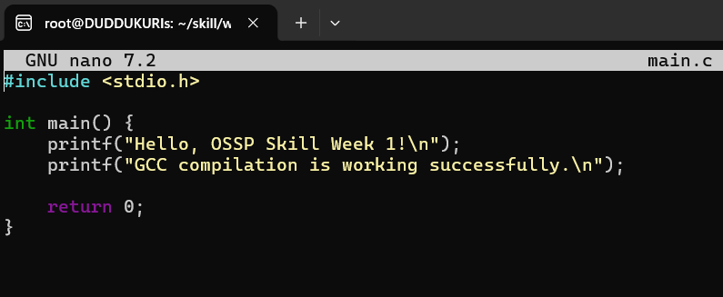
OUTPUT:
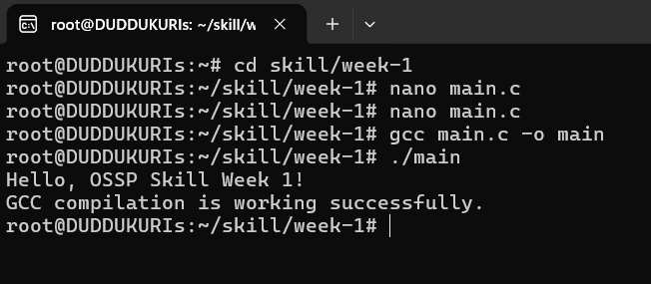
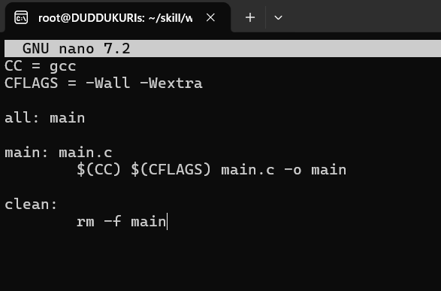
Verifying linux environment by uname-a:
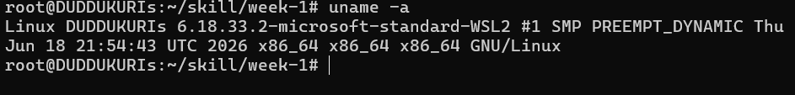
Checking GCC C compiler:
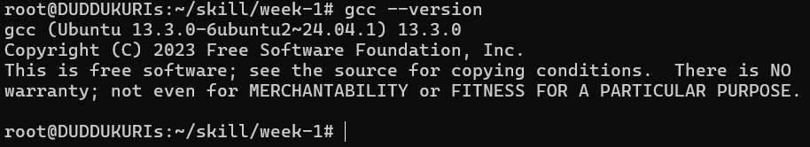
Git version:
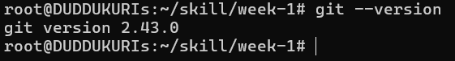

Task 2: To Analyse process abstraction, execute fork(), understand exec() family, analyse parent-child relationships, inspect process tree, practice system call tracing.
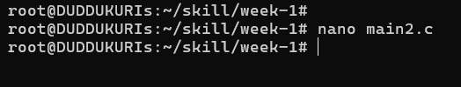
CODE:
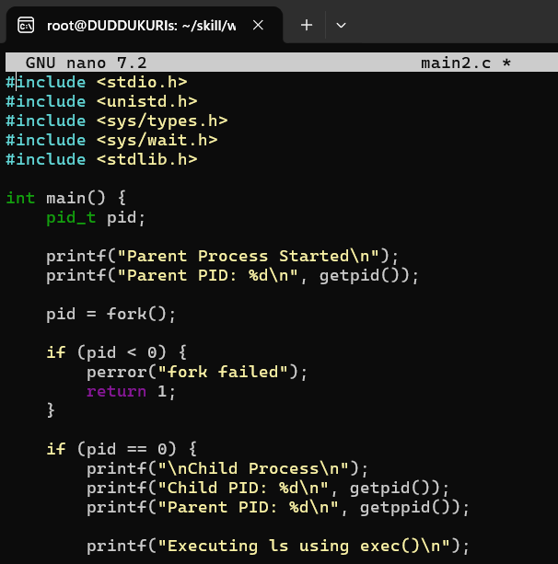
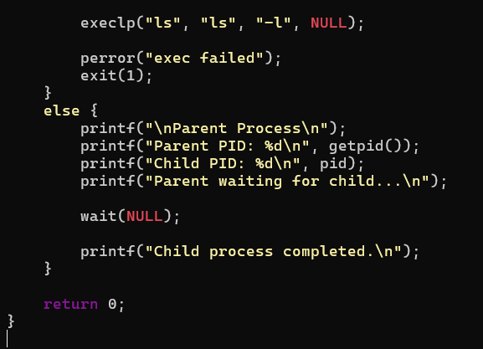
OUTPUT:
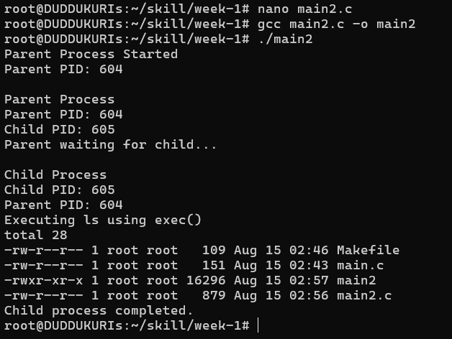
SESSION-2
Task 1: To Create Main Loop, Display Prompt, Read User Input, Handle Exit Conditions, Design Control Flow Diagram, Test Interactive Loop
- Create a file by using
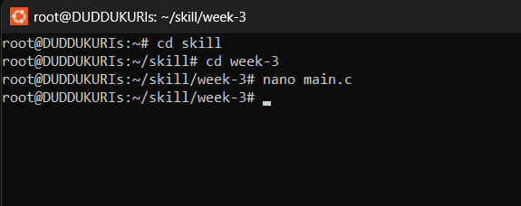
Then press enter and the code terminal will open then write a code
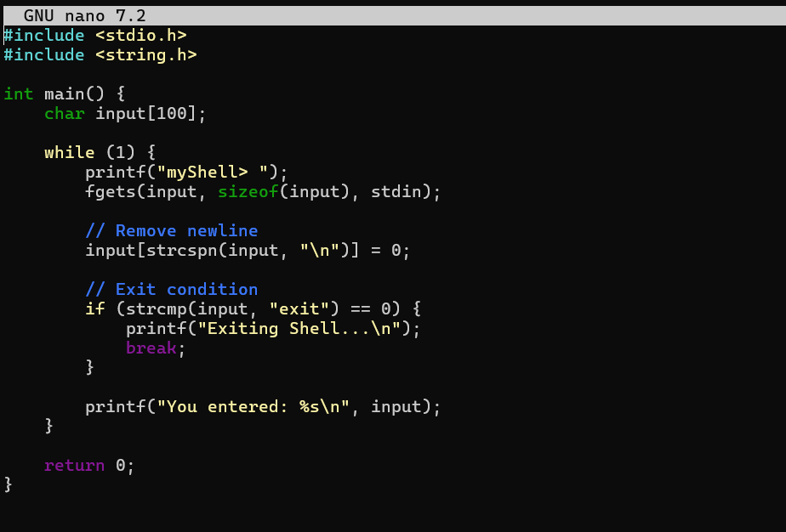
After writing the code save the your program by ctrl O and for coming back to command press ctrl X then compile it by the command
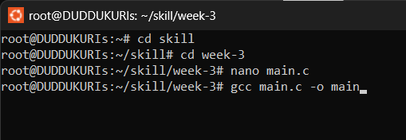
After compiling to get the output enter command
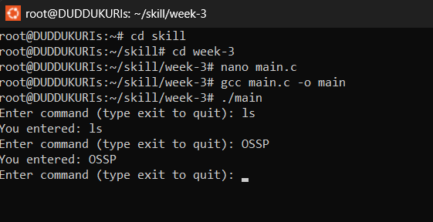

Task 2: To Capture Keyboard Input, Handle Backspace, Process Enter Key, Manage Input Buffer, Support Multi-Character Commands, Test User Interaction.
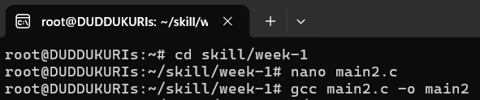

CODE:
